Embedded Systems Hardware and Software Technologies

Bhavneet Soni

Author’s Note

Amazing thing about embedded systems is that users are seldom aware of the computing power they have. Embedded systems are computer systems with a limited but dedicated purpose. These are present in all the electronic and most electrical machines. 98% of all the microprocessors manufactured are parts of embedded systems. One of the earliest embedded system was the guidance system for Apollo missions. In this report, we will discuss various embedded hardware and software technologies available and used these days.

**Embedded Systems Hardware and Software Technologies**

Embedded Systems are small computer systems integrated with is a system that has software embedded into hardware, Which is a framework application (s) or a particular part of the application or item or part of a bigger framework is committed to. Their nearness is a long way from clear to the easygoing eyewitness. Embedded systems are found in phones, computerized cameras, camcorders, convenient computer games, number crunchers, and individual advanced partners, microwave stoves, voice-mail, home security frameworks, clothes washers, lighting frameworks, fax machines, copiers, printers, and scanners, money registers, alert frameworks, robotized teller machines, transmission control, journey control, fuel infusion, non-freezing stopping devices, dynamic suspension and numerous different gadgets/contraptions. It forms a settled arrangement of pre-modified directions to control electromechanical gear which might be a piece of a significantly bigger framework (not a PC with console, show, and so on).

An embedded system is a system including calculation that is liable to physical requirements (response imperatives and execution limitations) emerging through communications of computational procedures with the physical world. Response imperatives begin from the behavioral prerequisites and determine due dates, throughput, and jitter though execution limitations start from the usage necessities and put limits on accessible processor speeds, power, memory and equipment disappointment rates. The way to embedded systems outline is to acquire wanted usefulness under both sorts of imperatives.

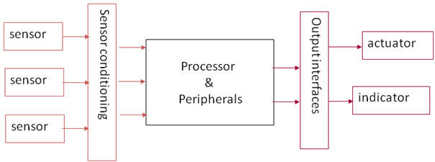

Figure 1Block Diagram Embedded System (Jain, 2012)

**CHARACTERISTICS**

a)    Embedded systems are application particular and single worked; application is known apriori, the projects are executed more than once.

b)    Efficiency is of central significance for embedded systems. They are improved for vitality, code measure, execution time, weight and measurements, and cost.

c)    Embedded systems are ordinarily intended to meet continuous limitations; an ongoing system responds to boosts from the controlled question/administrator inside the time interim directed by the earth. For constant systems, right answers arriving past the point of no return (or even too soon) aren't right.

d)   Embedded systems frequently associate (sense, control and convey) with outer world through sensors and actuators and thus are regularly receptive systems; a responsive system is in ceaseless collaboration with the earth and executes at a pace controlled by that environment.

e)    They for the most part have negligible or no UI.

* **Single-functioned** − An embedded system ordinarily plays out a specific operation and does likewise over and again. For instance: A pager dependably works as a pager.
* **Tightly constrained** − All figuring systems have limitations on plan measurements, yet those on an embedded system can be particularly tight. Plan measurements is a measure of a usage's components, for example, its cost, size, power, and execution. It must be of a size to fit on a solitary chip, must perform sufficiently quick to process information progressively and devour least energy to broaden battery life.
* **Reactive and Real time** − Numerous embedded systems should constantly respond to changes in the system's surroundings and must register certain outcomes progressively immediately. Consider a case of an auto journey controller; it ceaselessly screens and responds to speed and brake sensors. It must register increasing speed or de-increasing velocities over and again inside a constrained time; a postponed calculation can bring about inability to control of the auto.
* **Microprocessors based** − It must be microchip or microcontroller based.
* **Memory** − It must have a memory, as its product typically installs in ROM. It needn't bother with any auxiliary recollections in the PC.
* **Connected** − It more likely than not associated peripherals to interface info and yield gadgets.
* **HW-SW systems** − Programming is utilized for more components and adaptability. Equipment is utilized for execution and security.

The following illustration shows the basic structure of an embedded system −

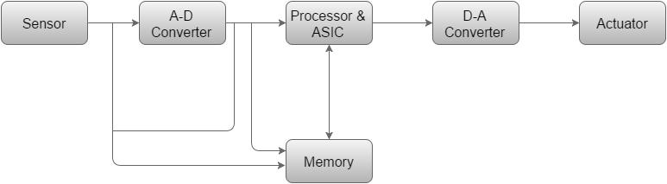

* **Sensor** − It gauges the physical amount and changes over it to an electrical flag which can be perused by an eyewitness or by any electronic instrument like an A2D converter. A sensor stores the deliberate amount to the memory..
* **A-D Converter** − An analog-to-digital converter converts the analog signal sent by the sensor into a digital signal.
* **Processor & ASICs** − Processors handle the information to quantify the yield and store it to the memory.
* **D-A Converter** − A computerized to-simple converter changes over the advanced information bolstered by the processor to simple information
* **Actuator** − An actuator thinks about the yield given by the D-A Converter to the real (expected) yield put away in it and stores the affirmed yield.

Processor is the heart of an embedded system. It is the fundamental unit that takes sources of info and produces a yield in the wake of handling the information. For an embedded system planner, it is important to have the information of both chip and microcontrollers.

Processors in a System

A processor has two essential units −

* Program Flow Control Unit (CU)
* Execution Unit (EU)

The CU incorporates a get unit for bringing directions from the memory. The EU has circuits that actualize the guidelines relating to information exchange operation and information transformation starting with one frame then onto the next.

The EU includes the Arithmetic and Logical Unit (ALU) and also the circuits that execute instructions for a program control task such as interrupt, or jump to another set of instructions.

A processor runs the cycles of fetch and executes the instructions in the same sequence as they are fetched from memory.

Types of Processors

Processors can be of the following categories −

* General Purpose Processor (GPP)
  + Microprocessor
  + Microcontroller
  + Embedded Processor
  + Digital Signal Processor
  + Media Processor
* Application Specific System Processor (ASSP)
* Application Specific Instruction Processors (ASIPs)
* GPP core(s) or ASIP core(s) on either an Application Specific Integrated Circuit (ASIC) or a Very Large Scale Integration (VLSI) circuit.

Microprocessor

A microchip is a solitary VLSI chip having a CPU. What's more, it might likewise have different units, for example, mentors, drifting point preparing number juggling unit, and pipelining units that assistance in speedier handling of guidelines.

Prior era microchips' bring and-execute cycle was guided by a clock recurrence of request of ~1 MHz. Processors now work at a clock recurrence of 2GHz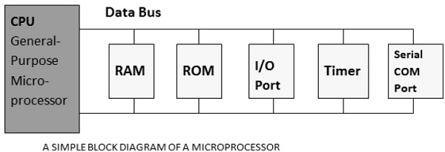

Microcontroller

A microcontroller is a solitary chip VLSI unit (likewise called microcomputer) which, despite the fact that having constrained computational abilities, has upgraded input/yield capacity and various on-chip useful units.

|  |  |  |
| --- | --- | --- |
| CPU | RAM | ROM |
| I/O Port | Timer | Serial COM Port |

Microcontrollers are especially utilized as a part of embedded systems for continuous control applications with on-chip program memory and gadgets.

Let us now investigate the most remarkable contrasts between a microchip and a microcontroller.

|  |  |
| --- | --- |
| **Microprocessor** | **Microcontroller** |
| Microprocessors are multitasking in nature. Can perform multiple tasks at once. For instance, we can play music while composing content in content editor | Single task oriented. For example, a washing machine is designed for washing clothes only. |
| RAM, ROM, I/O Ports, and Timers can be customized and be added externally and can vary in numbers. | RAM, ROM, I/O Ports, and Timers cannot be added externally. These components are to be embedded together on a chip and are fixed in numbers. |
| Designers can decide the number of memory or I/O ports needed. | Fixed number for memory or I/O makes a microcontroller ideal for a limited but specific task. |
| External support of external memory and I/O ports makes a microprocessor-based system heavier and costlier. | Microcontrollers are lightweight and cheaper than a microprocessor. |
| External devices require more space and their power consumption is higher. | A microcontroller-based system consumes less power and takes less space. |

References

(n.d.). Retrieved from https://www.tutorialspoint.com/embedded_systems/es_overview.html

Jain, P. (2012). Retrieved from www.engineersgarage.com: http://www.engineersgarage.com/articles/embedded-systems